**Theory**

We want to calculate thermodynamic expectation values

$$\left\langle O\right\rangle =\frac{\operatorname{tr}\left[e^{-βH}O\right]}{\operatorname{tr}\left[e^{-βH}\right]}=\frac{1}{\operatorname{tr}\left[e^{-βH}\right]}\sum_{n}{\left\langle n\right|e^{-βH}O\left|n\right\rangle }=\frac{1}{\operatorname{tr}\left[e^{-βH}\right]}\sum_{n}{e^{-βE_{n}}\left\langle n\right|O\left|n\right\rangle }$$

We need to diagonalize the Hamiltonian. For this to work, we need to find its matrix elements. The Hamiltonian is

$$H=\frac{J_{xy}}{2}\sum_{j=1}^{L}{\left[S_{j}^{+}S_{j+1}^{-}+S_{j}^{-}S_{j+1}^{+}\right]}+J_{z}\sum_{j=1}^{L}{S_{j}^{z}S_{j+1}^{z}}-h\sum_{j=1}^{L}{S_{j}^{z}}$$

Several remarks are in order. Firstly, this Hamiltonian conserves the total spin, i.e. when applied to any state it does not change the number of spins up (or down) in this state. This means that in the basis $\left|s_{1},…,s_{L}\right\rangle$ it is block-diagonal. We can split up the state-sum as follows:

$$\sum_{n}{∙}→\sum_{\begin{aligned}h \\ \text{subspaces}\end{aligned}}{\sum_{\begin{aligned}s \\ \text{basis state}\end{aligned}}{∙}}$$

$h$ denotes the subspaces, $s$ denotes the basis states within this subspace. We find that

$$Z=\operatorname{tr}\left[e^{-βH}\right]=\sum_{n}{e^{-βE_{n}}}=\sum_{\begin{aligned}h \\ \text{subspaces}\end{aligned}}{\sum_{\begin{aligned}s \\ \text{basis state}\end{aligned}}{e^{-βE\left(h, s\right)}}}=\sum_{\begin{aligned}h \\ \text{subspaces}\end{aligned}}{Z\left(h\right)}$$

$$\operatorname{tr}\left[e^{-βH}O\right]=\sum_{\begin{aligned}h \\ \text{subspaces}\end{aligned}}{\sum_{\begin{aligned}s \\ \text{basis state}\end{aligned}}{e^{-βE\left(h, s\right)}\left\langle s\right|O\left|s\right\rangle }}=\sum_{\begin{aligned}h \\ \text{subspaces}\end{aligned}}{{tr}_{h}\left[e^{-βH}O\right]}=\sum_{\begin{aligned}h \\ \text{subspaces}\end{aligned}}{{\left\langle O\right\rangle }_{h}Z\left(h\right)}$$

Hence:

$$\left\langle O\right\rangle =\frac{\sum_{\begin{aligned}h \\ \text{subspaces}\end{aligned}}{{tr}_{h}\left[e^{-βH}O\right]}}{\sum_{\begin{aligned}h \\ \text{subspaces}\end{aligned}}{Z\left(h\right)}}=\frac{\sum_{\begin{aligned}h \\ \text{subspaces}\end{aligned}}{{\left\langle O\right\rangle }_{h}Z\left(h\right)}}{\sum_{\begin{aligned}h \\ \text{subspaces}\end{aligned}}{Z\left(h\right)}}$$

The subspaces can be labelled by the number of spins up. There are $L+1$ such subspaces; write

$$Z\left(h\right)→Z_{k}$$

Then,

$$\left\langle O\right\rangle =\frac{\sum_{k=0}^{L}{{\left\langle O\right\rangle }_{k}Z_{k}}}{\sum_{k=0}^{L}{Z_{k}}}$$

Also, the Hamiltonian is symmetric under a sign flip. More precisely, we have

$$H\left(h\right)→H\left(-h\right)$$

Without the magnetic field, then, we know that

$$Z_{k}=Z_{L-k}$$

i.e. it does not matter whether we look at the state as having $k$ spins up or $k$ spins down. This then further simplifies the equation

$$Z=\sum_{k=0}^{L}{Z_{k}}=2\sum_{k=0}^{\left\lfloor \frac{L}{2}\right\rfloor }{Z_{k}}, L \text{odd}$$

We need to go from $0$ to $\frac{L-1}{2}$ spins up, that’s the first half of the subspaces that are equivalent to the remaining $\frac{L+1}{2}$.

$$Z=2\sum_{k=0}^{\frac{L}{2}-1}{Z_{k}}+Z_{\frac{L}{2}}, L \text{even}$$

This is because for $L$ even, there is an odd ($L+1$) number of such subspaces. We count all with $0$ up until $\frac{L}{2}-1$ spins up. Then there is the one with $\frac{L}{2}$ spins up and down, and the remaining ones are equivalent to the previous $\frac{L}{2}-1$.

Now, switch on the magnetic field, we get

$$Z_{k}=\sum_{{\left\{s\right\}}_{k}}{e^{-β\left[\frac{J_{xy}}{2}\sum_{j=1}^{L}{\left[S_{j}^{+}S_{j+1}^{-}+S_{j}^{-}S_{j+1}^{+}\right]}+J_{z}\sum_{j=1}^{L}{S_{j}^{z}S_{j+1}^{z}}-h\sum_{j=1}^{L}{S_{j}^{z}}\right]}}=\sum_{{\left\{s\right\}}_{k}}{e^{-βH_{0}}e^{βh\sum_{j=1}^{L}{S_{j}^{z}}}}$$

In subspace $k$, the last term is always equal to

$$\sum_{j=1}^{L}{S_{j}^{z}}=-\frac{\left(L-k\right)}{2}+\frac{k}{2}=-\frac{L}{2}+k$$

Hence,

$$Z_{k}=\sum_{{\left\{s\right\}}_{k}}{e^{-βH_{0}}e^{βh\left(-\frac{L}{2}+k\right)}}=e^{βh\left(-\frac{L}{2}+k\right)}\sum_{{\left\{s\right\}}_{k}}{e^{-βH_{0}}}=e^{βh\left(-\frac{L}{2}+k\right)}Z_{k}^{0}$$

We learned that

$$Z=\sum_{k}{e^{βh\left(-\frac{L}{2}+k\right)}Z_{k}^{0}}$$

Now, exchange $k→L-k$, then

$$e^{βh\left(\frac{L}{2}-k\right)}Z_{k}^{0}→e^{βh\left(-\frac{L}{2}+k\right)}Z_{L-k}^{0}=e^{-βh\left(\frac{L}{2}-k\right)}Z_{k}^{0}$$

Plugging this into the formula above, we get

$$Z=\sum_{k=0}^{L}{Z_{k}\left(h\right)}=\sum_{k=0}^{\left\lfloor \frac{L}{2}\right\rfloor }{\left(e^{βh\left(\frac{L}{2}-k\right)}+e^{-βh\left(\frac{L}{2}-k\right)}\right)Z_{k}^{0}}=2\sum_{k=0}^{\left\lfloor \frac{L}{2}\right\rfloor }{\cosh\left(βh\left(\frac{L}{2}-k\right)\right)Z_{k}^{0}}+\left(1-D\right)Z_{\frac{L}{2}}^{0}$$

where the last term corresponds to the case where $L$ is even. In this case, the middle subspace has $m=0$.

**The Hamiltonian**

We encode all $2^{L}$ spin combinations as binary numbers from $0$ to $2^{L}-1$. In the for-loop, we get the state $s_{1}s_{2},…,s_{L}$.

The $J_{z}$-term and the $h$-term are diagonal: for each diagonal entry you iterate $i$ from $0$ to $L-1$ and add

$$\left(s_{i}-\frac{1}{2}\right)\left(s_{i+1}-\frac{1}{2}\right)$$

for the $J_{z}$-term and

$$-hs_{i}$$

for the $h$-term. If we are within a subspace, we can simply add

$$-h\left(-\frac{L}{2}+k\right)$$

to every diagonal entry.

We want the expectation value of several operators, including magnetization:

$$M=\sum_{j=1}^{L}{S_{j}^{z}}$$

For the $J_{xy}$-term, we will have to be more careful. We iterate $i$ from $0$ to $2^{L}$ and look at the bit-representation with $L$ digits of $i$. This represents a spin state. Traversing the state from left to right, we notice that if two adjacent spins are unequal, they will contribute

$$\frac{J_{xy}}{2}$$

to the spin-flip term; here, the other index is the number we get when we take $i$ and exchange the two bits.

We are interested in expectation values of $M$ and $M^{2}$. But both are block-diagonal, just as $H$, and furthermore, on each are just multiples of the unit matrix with a value

$$M=mI, M^{2}=m^{2}I$$

In the general formula

$$\left\langle O\right\rangle =\frac{\sum_{k=0}^{L}{{\left\langle O\right\rangle }_{k}Z_{k}}}{\sum_{k=0}^{L}{Z_{k}}}$$

then, we know that ${\left\langle M\right\rangle }_{k}=\left(-\frac{L}{2}+k\right), {\left\langle M^{2}\right\rangle }_{k}={\left(-\frac{L}{2}+k\right)}^{2}$. Once we have calculated the partition sums, it is very easy to calculate these expectation values.

**Results, Thermodynamics**

Magnetization per site, $J_{z}=J_{xy}=0$, $L=15$ (free paramagnet):

Magnetization per site, , :

From here:

BEHAVIOUR: ANTI-FERROMAGNETIC

Same thing, but with negative coupling,

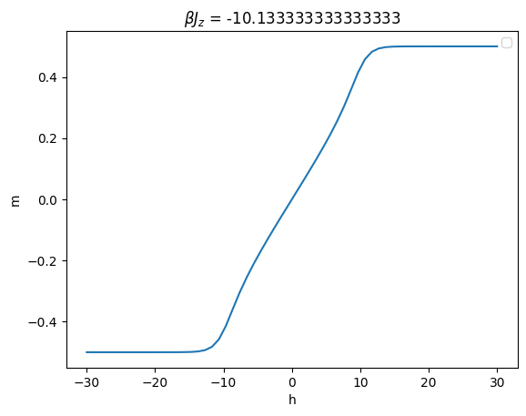

Susceptibility as a function of

Ground-State energy: positive $J$

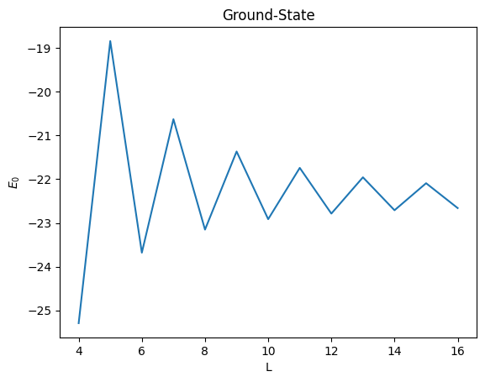

Negative $J$

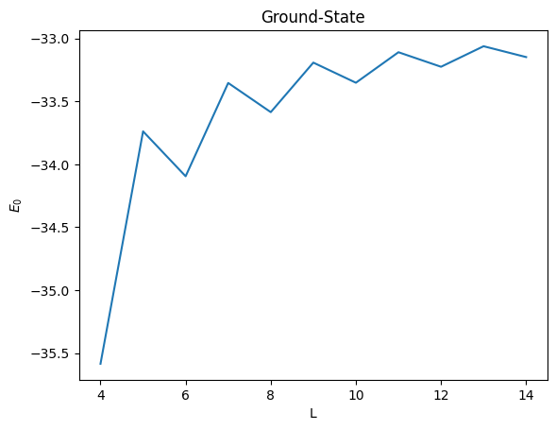

**Results, Dynamics of the system**

Let’s also calculate the matrix exponential in non-diagonal form and find the time-evolution operator

